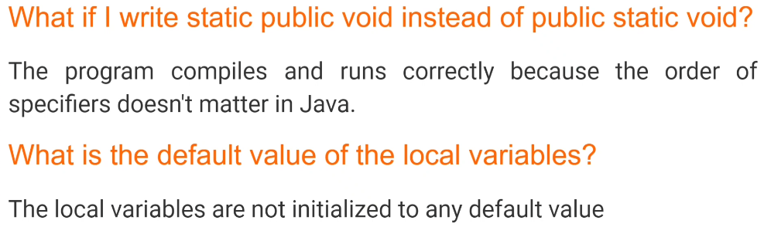

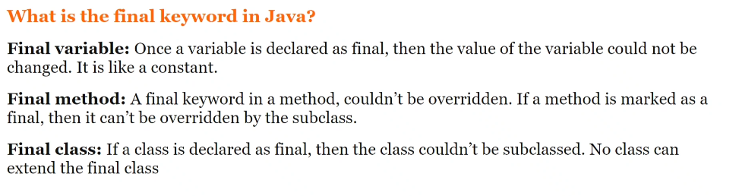

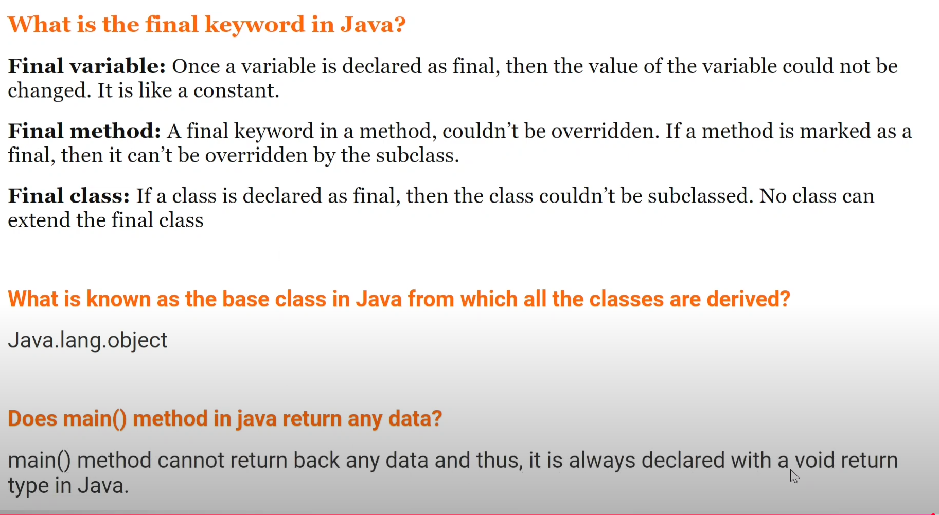

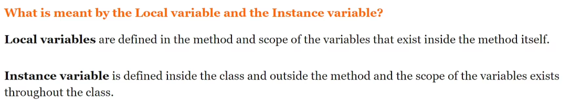

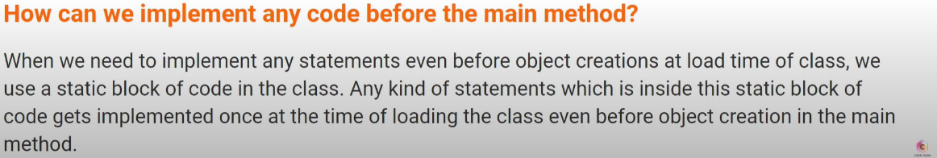

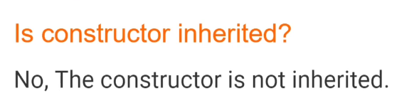

Constructor’s can not be final, abstract, static and synchronized

